Error message not displayed after entering invalid customer ID
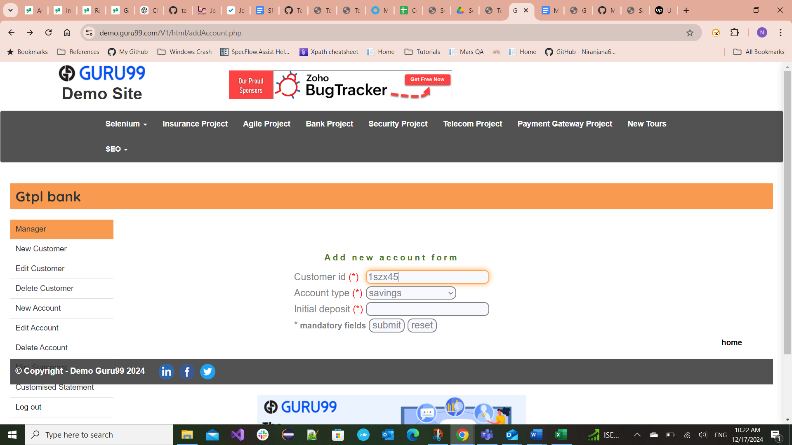

Error message not displayed after entering Invalid characters in customer ID
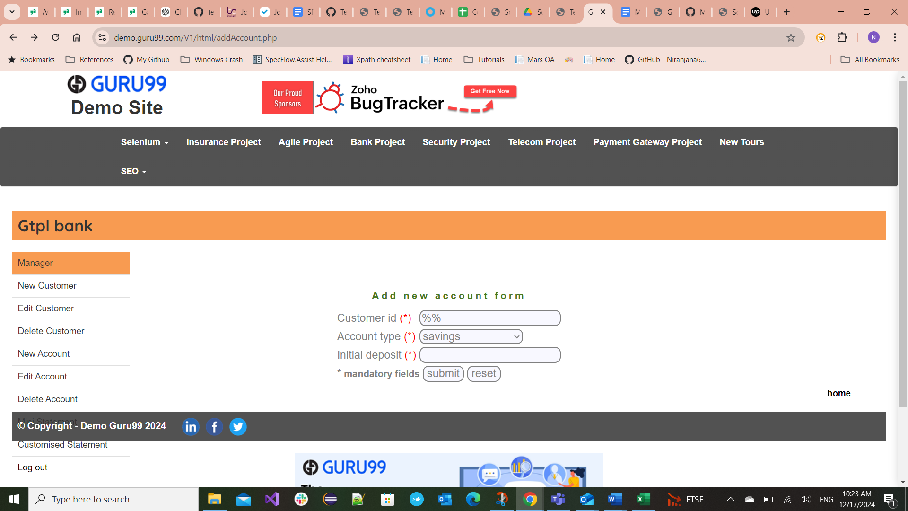

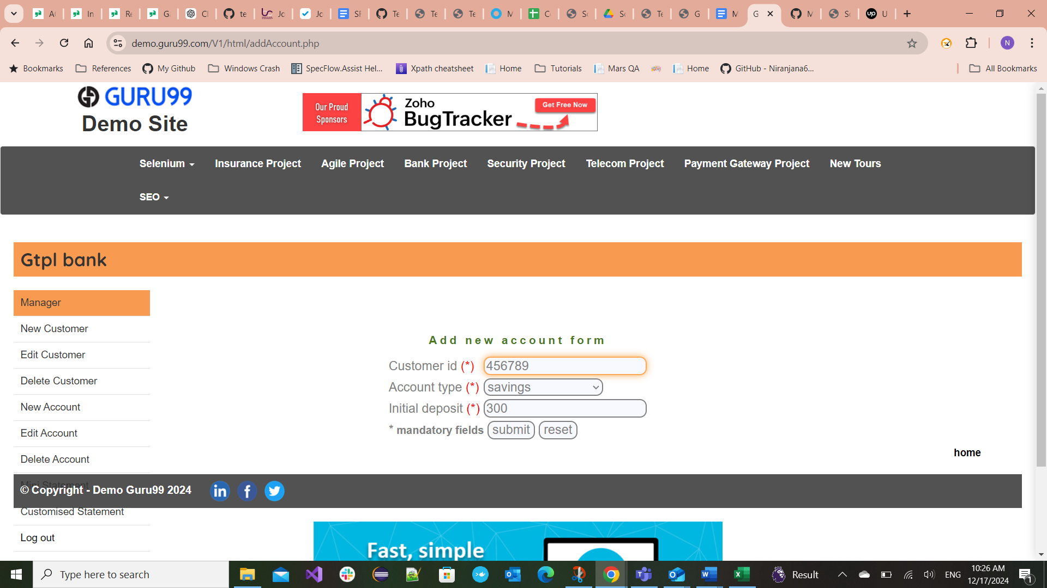
Error message not displayed on entering Initial deposit less than 500

